Name: Caitlin Jung

**CS3431-A19 Wong**

**Assignment 4: Entity-Relationship Diagrams**

Due Date: M 9/16 at 11:59pm

Late Policy: no late submissions because solutions will be posted on Wednesday so you can correct any errors before your Project 1 submission.

Submission: Use LucidChart to create your diagrams and then download the images to your computer. For your assignment, include the title “Assignment 4” and your name at the top of the document, and submit paste the images into your document and submit as a Word (.doc, .docx) or PDF document.

**(25 points) Problem 1 – Cruise Ship**

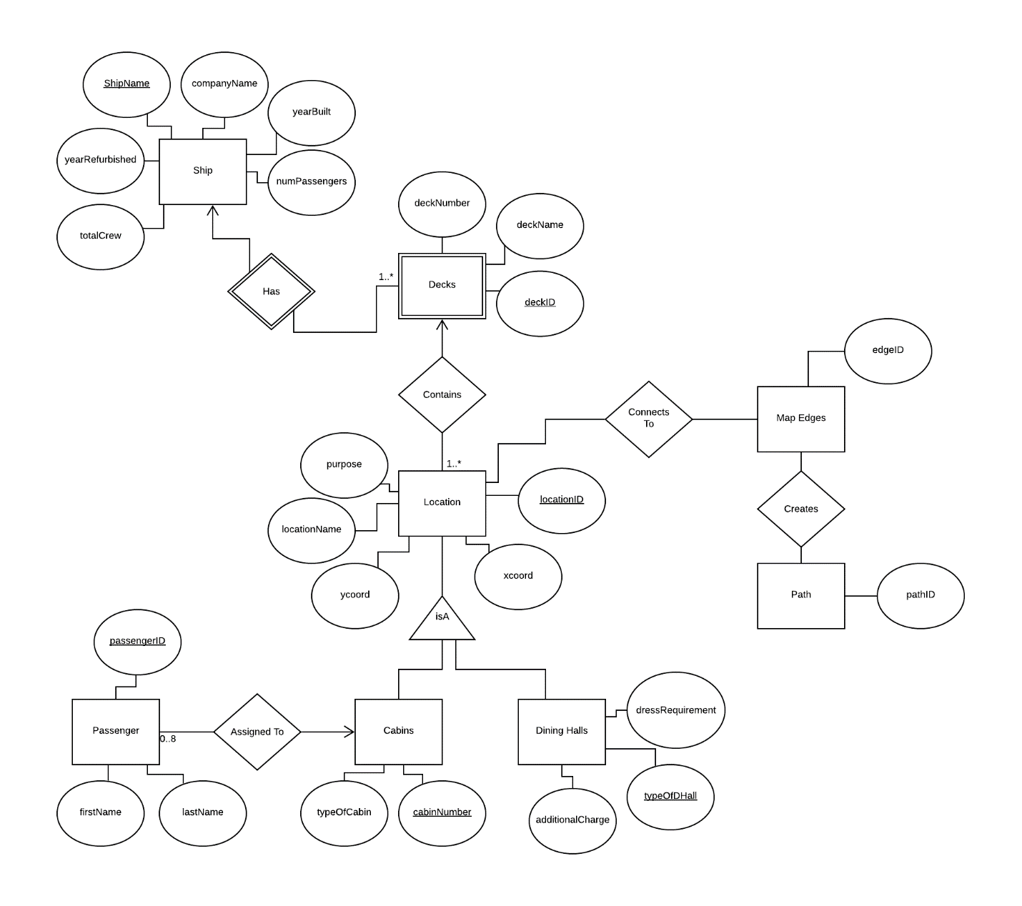

Note: The line under deckID for Decks should be dashed but LucidChart does not dashed-underline words.

**(20 points) Problem 2a – Symphony**

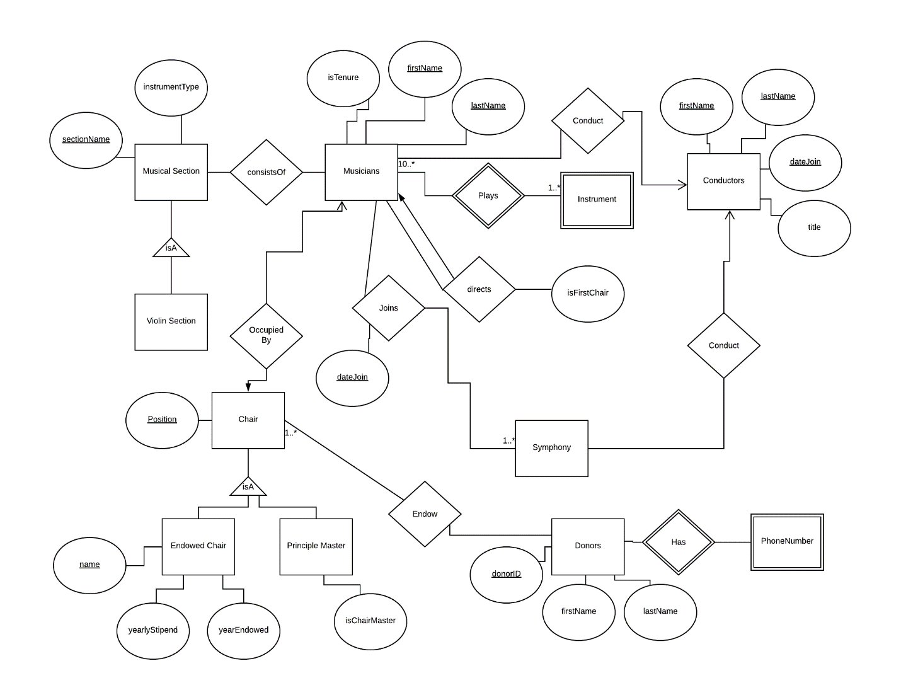

**(5 points) Problem 2b**

The same information as in Problem 2a but musicians have a unique ID assigned to them.

